INTRODUCTORY BIOSTATISTICS:

Analysis of Variance (ANOVA)
Goals
· Learn how to use ANOVA to assess group differences in means.
· Learn how to compute subgroup means and how to perform multiple comparisons of means.
· Interpret the results of ANOVA.

Reading Assignment
· Read Chapter 12 in the textbook.

Introduction
So far in this course we have been examining different ways to compare two groups of subjects on the distributions of variables of interest. The T-test can be used to test the null hypothesis that 2 groups have the same mean value of some variable. Analysis of variance (ANOVA) is another useful tool, and it has many advantages over the 2-sample T test. ANOVA can be used to generate a single P-value to test the null hypothesis that 3 or more groups have the same mean value of the study variable (as opposed to doing multiple T-tests, each with its own significance test at the .05 level, among the pairs of groups means, leading to an increased "risk" of finding a significant result purely by chance). The collection of variables that go into an ANOVA is referred to as the "model": there is a single dependent variable (also called the outcome variable) and one or more independent variables. ANOVA can generate adjusted group means that take into account the influence of multiple factors in the model.
​It is always important to think about the underlying assumptions of statistical tests. For ANOVA, there must be independent observations, normal distributions in the continuous variables, and homogeneity of variance among the groups. When one or more of these assumptions is not met, one can turn to alternative statistics that do not have the same restricting assumption, or "transform" non-normal variables into more normal approximations. The usual data exploration techniques (data plots, means, medians, and standard errors, for example) can be used to examine certain of these assumptions.

Homework

PART (A): A study in the city of Baltimore examined blood lead levels of children between the ages of 2 and 4 in relation to the location of the child's residential neighborhood. Due to past deposition of inorganic lead from leaded gasoline into the environment, neighborhoods near major roads and highways ("A" neighborhoods) were hypothesized to have somewhat higher levels of lead in soil and houses, compared to neighborhoods located between 1 and 5 miles away from the highways ("B" neighborhoods) and neighborhoods located more than 5 miles away from the highway ("C" neighborhoods). Blood lead levels are a marker of environmental exposure and body burden of this toxic metal. There is some suggestion in the literature of gender differences in blood lead levels and the investigators want to explore this relationship in their data.

Your assignment is to use one-way ANOVA models to separately evaluate if there are gender differences on blood lead levels and also if there are neighborhood differences regarding blood lead levels.

You should:
- run a one-way ANOVA model to test if there are neighborhood differences in blood lead levels

pvalue=7.92626068744793e-23
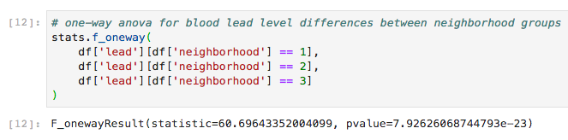

- run a one-way ANOVA model to test if there are gender differences in blood lead levels

pvalue=0.9418531343044891
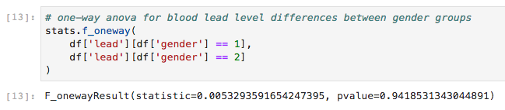

- do the same using the t-test and compare the results

pvalue=0.9418531343045176
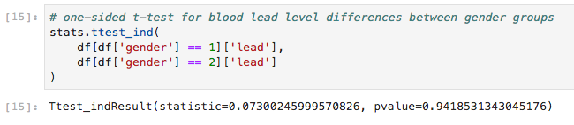

- answer the questions on the worksheet.

Data
The variables are neighborhood (1=A, 2=B, 3=C, as defined above), gender (1=male, 2=female), and blood lead(micrograms per deciliter of whole blood). Import the Excel file named Lead.xls into STATA.

PART (B): A clinical trial examined the efficacy of 3 types of medications in lowering total blood cholesterol levels. All participants in the trial were adults with high (>250 mg/dL) cholesterol levels, previously untreated. There was no placebo group, as it was felt that all subjects should have some chance to receive an effective medication to treat their condition. The cholesterol variable is the final measurement taken at the end of the trial. Your assignment is to perform ANOVA to evaluate which medication is most efficacious for blood cholesterol control (assuming that lower levels are best!).

- ​run a one-way ANOVA model to evaluate the effects of medications

F_onewayResult(statistic=5.494053001321553, pvalue=0.010851498057733687)

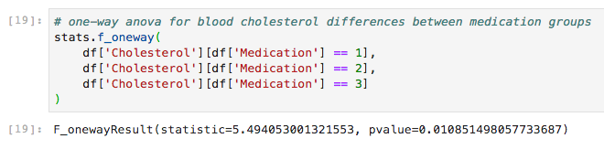

- ​compute the mean cholesterol levels

Medication Mean
1 198.666667
2 182.888889
3 198.333333
All Obsv. 193.296296
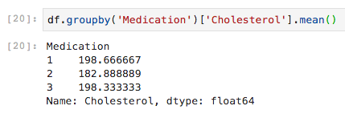

- ​determine which medication was best, using the Bonferroni method for the one-way ANOVA model

Bonferroni alpha to use: 0.0167 (.05/3)
T-test 1: med 1 and med 2 = pvalue=0.0118
T-test 2: med 1 and med 3 = pvalue=0.9518
T-test 3: med 2 and med 3 = pvalue=0.0105
Medication 2 appears to have the most significant effect in lowering blood cholesterol levels.
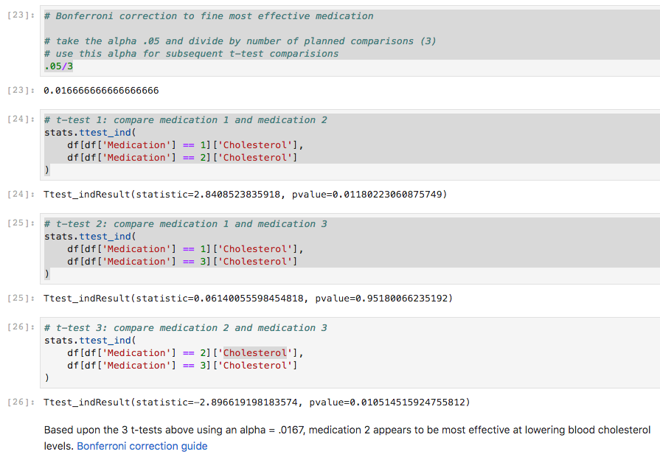

- ​answer the questions on the worksheet

Data
The variables are medication (1, 2, or 3), age, body mass index, and cholesterol. Import the Excel file named Cholesterol.xls into STATA.

PART A {Blood Lead Data}

1. What are the assumptions for this model, and were they true?

The ANOVA test has important assumptions that must be satisfied in order
for the associated p-value to be valid.

A. The samples are independent - This is true because the measurements of individuals blood lead levels within each given neighborhood neither depended on previous measurements nor affected following measurements of individuals.

B. Each sample is from a normally distributed population - To check that the population has a normal distribution I generated histograms counting the blood lead level frequency by neighborhood as well as in aggregate (we have a continuous outcome variable with a central tendency that follows a bell-shaped curve)

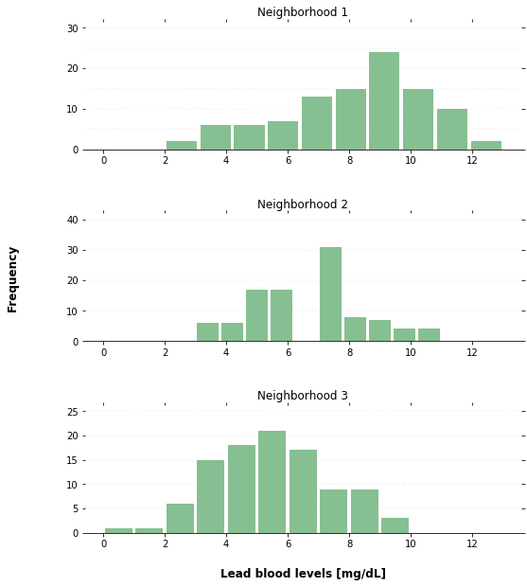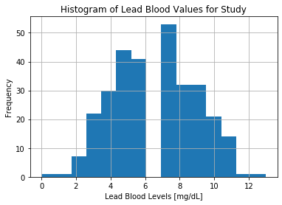

C. The population standard deviations of the groups are all equal (homogeneity of variance across the three groups) - I checked the standard deviations of lead levels grouped by neighborhood to find the stdev is approximately 2 for each of the three groups (all three groups have approximately the same variance), and all groups contain 100 individuals (equal group sizes)

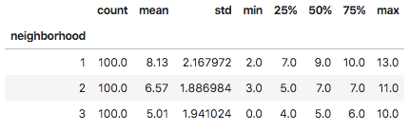

Hypothesis for the mean blood lead levels by neighborhood model:
H₀= µ_{neighborhood_1}=µ_{neighborhood_2}=µ_{neighborhood_3}
H_{A}= at least one of the neighborhood mean blood lead levels is different from the others

2. What is the overall F-test result from the one-way ANOVA model for neighborhood? F=60.6964, P=7.9262e-23
F_onewayResult(statistic=60.69643352004099, pvalue=7.92626068744793e-23)

Interpretation: The difference between group means is statistically significant (p-value of 7.93e-23 < .05) and the null hypothesis that the mean blood lead levels for each neighborhood are equal can be rejected. Using the Bonferroni correction method to compare each neighborhood it appears that there is a statistical significance between each of the groups. Using a boxplot to separate the blood lead values by neighborhood, it becomes apparent that the blood lead levels decrease in neighborhoods that are further from highways.
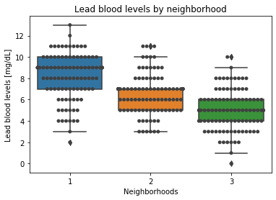

3. What is the overall F-test result from the one-way ANOVA model for gender?
F =0.00533, P=0.94185
F_onewayResult(statistic=0.0053293591654247395, pvalue=0.9418531343044891)

H₀= µ_{males}=µ_{females}
H_{A}= one gender mean blood lead level is different from the other

Interpretation: Using a one-way ANOVA to analyze the variance in blood lead levels by gender (between males and females) I found there to be no statistically significant difference between the group means, thus I cannot reject the null hypothesis that the mean blood lead levels between males and females are equal.

4. What is the t-test result for gender?
T statistic =0.07300, P=0.94185
Ttest_indResult(statistic=0.07300245999570826, pvalue=0.9418531343045176)

Compare this result with the result from the one-way ANOVA model:
Although the t- and f-statistic differ between the one-sided T-test and the ANOVA model, the p-values are nearly identical (.94185). In comparing the mean blood lead levels by gender, both models come to the same conclusion in that the null hypothesis cannot be rejected.

PART B - {Cholesterol Drug Trial Data}

1. What is the:
- SS for treatment in the medication one-way ANOVA model: 1462.74
- Degrees of freedom for treatment: 3
- SS error: 37.73

2. Report and interpret the overall F-test from the one-way ANOVA model for medication.
F=5.49405, P=0.01085
F_onewayResult(statistic=5.494053001321553, pvalue=0.010851498057733687)

Interpretation: Using the one-way ANOVA model to analyze the variance in mean blood cholesterol values between medication groups I find that there is a statistically significant difference between the group means as the p-value of 0.01085 < .05. The null hypothesis for the ANOVA model can be rejected, meaning that at least one of the medication group’s mean blood cholesterol value is different from the others, but until the Bonferroni correction method is applied it cannot yet be determined which group that is (though we’d get a hint by looking at the mean values for each medication group, see boxplot for the last question).

3. Provide the descriptive statistics below.
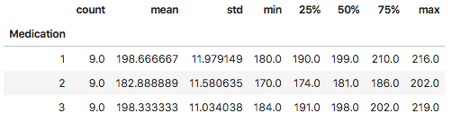

4. Interpret the results of the Bonferroni method for the three medications.

Following the Bonferroni correction method, the alpha value of .05 was divided bythe number of planned comparisions (3), resulting as: .05 / 3 = 0.0167, which is the be the alpha value used for the following T-test comparisons between medication groups. The following data summarizes the follow-up one-sided t-tests comparing the medication groups in a pairwise fashion.
- T-test 1: Medication 1 and Medication 2
  - T-statistic: 2.84085
  - P-value: 0.011802
- T-test 2: Medication 1 and Medication 3
  - T-statistic: 0.06140
  - P-value: 0.95180
- T-test 3: Medication 2 and Medication 3:
  - T-statistic: -2.8966
  - P-value: 0.01051

Based upon the 3 t-tests above using an alpha = .0167, medication 2 appears to be most effective at lowering blood cholesterol levels, which is also illustrated in the boxplot below.

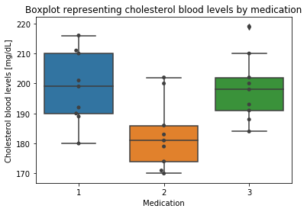
All Work:

